Tanner Wale

## **13 Best Practices on How to Improve Your Technical Skills**

How to improve technical skills? People can go several routes. Certifications, courses, projects, team projects, mentorships, etc. Each one has its benefits and depth to enhance technical skills. For me, I have done certifications, courses, education, projects, and real-world projects. All helped me reach my goal as a Help Desk Technician.

## **Technical Skills**



Two men looking at a laptop

Photo by olia danilevich: <https://www.pexels.com/photo/two-men-looking-at-a-laptop-4974920/>

What are technical skills? Technical skills can also be mentioned as hard skills. Technical skills refer to the abilities or specific knowledge required for performing tasks. Usually gained through college, certifications, or experiences. Technical skills can require hardware, software, or specialized equipment to complete complex jobs. These skills are measurable by some interviews requiring a technical assessment before offering you the job. Hence, why practice is important in technical skills.

## **Certifications**



Doctor wearing blue scrub suit

Photo by Los Muertos Crew: <https://www.pexels.com/photo/a-doctor-wearing-blue-scrub-suit-8460158/>

Certifications help candidates stand out among their peers, especially in the Information Technology or IT field. As this shows a deep interest in areas related to, whatever the job may be. One benefit of taking certifications is learning the in-depth skills for the job you want. More precisely how to improve areas of slow efficiency or lack of understanding.

You can gain hands-on experience with the latest technology. Understand the learning curve of older technology to the latest trends of new technology. You can do simulations and quizzes that test your understanding of knowledge. Develop critical thinking skills and specialized skills. Relating to the hands-on experience of the job.

Let's say you are going for a job in data analysis. This job requires you to know Structured Query Language (SQL). There are commands an individual should know to get the job. This could be tested in a technical interview and measured against the knowledge of other qualified candidates.

Certifications that can help you stand out are Google’s Data Analytics Professional Certificate. This deals with SQL, Tableau, and Excel. Showcasing to potential employers you have more than just one skill in data analytics. You can use SQL and other tools to complete an analysis of data. Another certification for SQL experience is IBM’s Data Analyst Professional Certificate. Also, the Meta Data Analyst Professional Certificate deals with SQL-related tasks.

Gaining A+, Network+, and Security+ made me stand out among other highly qualified candidates. For a job role in Help Desk Support. This job was with Natural Rural Telecommunications Cooperative (NRTC). This is a third-party support company for other internet partners. They deal with troubleshooting routers, phones, emails, computers, cameras, etc.

These certifications deal with a multitude of scenarios of how to solve all areas previously mentioned. Improving upon your skillset of problem-solving with what to do in complex scenarios. They also provide common tools such as monitoring, or testing networking devices with Command Line Interface (CLI). How to ping a device, to test if it is able to connect to the network. To talk to other devices on the network. To gain this knowledge you can get certified which shows you know how to complete these tasks.

## **Education**

Education is another practice that helps in projects, studying, and learning tools. College builds a foundation of knowledge you can use later for technical interviews. You can build a portfolio of projects through your college work. Try to make a GitHub account and share links to repositories. To show off your college projects. As these show where your technical skills began, and how they have developed after you’ve graduated.

The college also gives experience in hands-on training for projects. By a professor who comes from a background in the field, you’re pursuing. This is beneficial in gaining feedback from someone who knows what it takes to succeed in the field. Also, conducting more closely related projects that tie into real-world projects.

An example of this would be from my cybersecurity courses in college. I was given an assignment to read captured packets in a network for vulnerabilities. This is a normal task that cybersecurity professionals use to find threats. To remediate them before they are able to infiltrate the network and cause harm.

The knowledge you learn from college is incredibly important as you advance your career. As you advance further and further along in college. Your problem-solving and critical thinking skills will be tested by writing papers and taking multiple tests. Fostering better use of technical skills and foundation of trial and error from projects in college. Allowing for several ways for you to resolve a complex issue when you’re working.

Another added benefit of going to college is gaining confidence in your technical skills, which you're not comfortable with. From personal experience in coding, I was unable to use C++ (programming language). I would rather use Python for solving complex issues. I was required to use C++ for one project, letting me get out of my comfort zone. Through this, I gained useful experience with what pros and cons C++ had compared to Python.



People Sitting Inside Well Lit Room

Photo by Pixabay: <https://www.pexels.com/photo/people-sitting-inside-well-lit-room-159740/>

## **SMART Goals**

Smart goals stand for Set clear, Measurable, Attainable, Relevant, and Time objectives. With SMART goals you’ll notice projects are much more attainable. Without trying to go from step 1 to expert. Setting small goals helps you build, and work on other technical skills or tools that you might have overlooked.

An example of this is when I set a SMART goal for learning React programming basics in 2 months. My measurable goal was to program with React every day for at least 2 hours. This is easily attainable, and my relevancy was for a website that is directly related to the IT field. Lastly, time objectives were 2 hours a day for a total of 14 hours a week. I was able to work on my technical skills using SMART goals. Setting these small goals helped me finish small parts of my project.

# 

Pink Notebook on the Table

Photo by Polina: <https://www.pexels.com/photo/pink-notebook-on-the-table-5717443/>

## **Projects**

Personal projects are a great way to improve technical skills. By experiencing new ways to learn for more demanding projects. Using the tools or technical skills that you have from certifications and education. You can showcase your level of expertise by using these tools.

Another example of a project I worked on, while in school was a programming project. I modeled a website from a video game called Ark. This game is about dinosaurs. Each dino or creature has a stat. With each level increase their stats go up a specific number. I was able to make a calculator of all dinosaurs's stats, with each level increase. With a max level of 1000 for each dinosaur.

There were also three more calculators that I made for dinosaurs’s weapons, torpor rate, and food. These are parts of the game as well, that have their own calculations. This helped users who played the game, understand more about how dinosaurs increase stats, eat, tame, etc.

Learning from this experience was beneficial to making better programs. What it takes to program a working calculator accurately. Also, help users in error control, by asking my family to use the calculators. This was a mind-blowing experience because no one used the device, as I expected. Instead, I would spend days implementing error control. To help guide users on how to use the calculators.

Overall, projects get you out of your comfortable environment. Most importantly it shows dedication to personal growth and gives you areas of improvement. Letting you learn from your mistakes on your own. Also, requiring looking through technical documentation for clues to solve your problem.



Three People Sitting Beside Table

Photo by Pixabay: <https://www.pexels.com/photo/three-people-sitting-beside-table-416405/>

## **Courses and Webinars**

Courses are different from certifications because they focus more on specific tasks for skills training. Certifications focus more on industry standards of knowledge tests. By taking these courses you can get certified to show you have gained the necessary technical skills.

Courses can give you a foundational knowledge of technical skills required to complete a task. Also, helps you refine your technical skills to meet demands, for completing the tasks. Depending upon the course and industry you are in. You can take a task you completed, through the use of technical skills. To use in your portfolio as well. Courses will get individuals confidence in the most sought-after areas of any industry.

Webinars are another great resource of help, to people looking to grow into new roles. As you get an expert’s opinion of technical skills to practice. A live session from anywhere with an internet connection. Learn alongside experts who can show and teach you, how to use technical skills in the industry (NUcamp, 2023). Building upon technical skills, while networking with connections, and actively involved in the community.



People Looking at Laptop Computer

Photo by Fox: <https://www.pexels.com/photo/people-looking-at-laptop-computer-1595391/>

## **Practice Regularly**

The best way to improve technical skills is through practice. This goes for anything people want to get better efficiency in, like learning a programming language. Improvement can be seen through the everyday use of technical skills. Upon showing potential employers, you thrive in working alone, as well as part of a group. Confidence will prosper as experience continues to build through the regular use of technical skills.

This gives important development to a person, before a real-world scenario. Having constant recognition and a schedule of when to practice, is vital for steady improvement over time. Also, allowing you to take in what resources are needed for certain projects.

From personal experience when I was working with React programming basics. I found out through research. React is better for the User Interface or UI. Then, basic HTML and Javascript, which I had been previously using. The UI is what a user sees and interacts with on a web page.

Meaning I would have to reprogram my work into a different language (React). Below are different programming languages. One on the bottom is React. The ones on the top are the basic programming languages (HTML and Javascript).

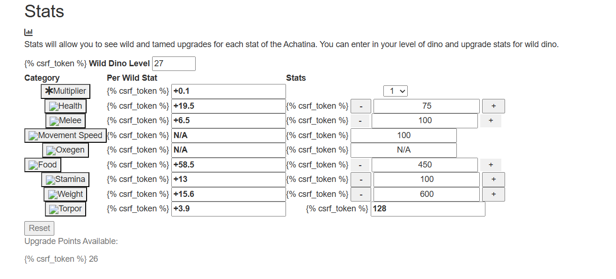

Table of stats displaying dinosaurs statistics

This is without CSS, which helps organize and color elements on the page. Even without CSS though, as you can see from the second image below. When you compare basic programming languages to React. It is much easier on the eyes because of the technology it uses.

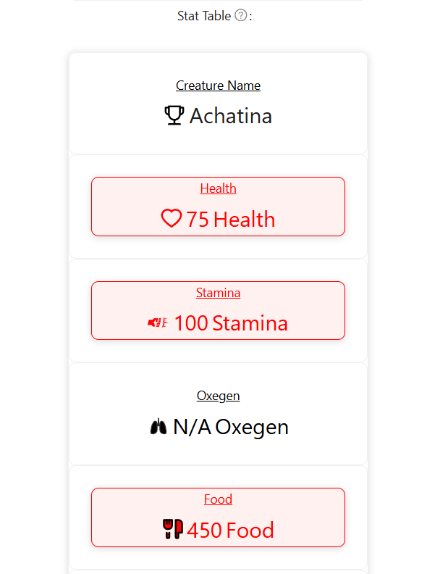

Table displaying stats of dinosaurs with colors.

## **Networking Groups**

Networking groups give you a chance to connect with people who share the best practices in the industry. This is where you can learn different ways to approach the same problem. By using the severity of the problem to determine what tool may work best. At a certain stage of resolving the issue at hand. Expanding your toolbox for technical skills. You can also learn about more helpful webinars, certifications, education, and more.

You can build connections through networking groups. Collaborate on challenging projects together for more learning experiences. You’ll learn about the latest technology trends, to keep you up-to-date. Get more direct knowledge from networking groups, possibly leading to a job later on.



Coworkers taking a coffee break

Photo by August de Richelieu: <https://www.pexels.com/photo/coworkers-taking-a-coffee-break-4427813/>

## **Mentorships**

Mentorships are helpful for advice on where improvement is needed for the mentee. Certain technical skills need reputational practice. With the help of mentorships, this is a faster process. As you do daily tasks the mentee has backup. In the event that the mentee does not have the necessary technical skills yet. To fix or reprogram to find a possible solution to an issue.

This fosters skill improvement in the most important areas of a company. While learning best practices in the industry. The mentorship will guide the mentees to what they're accountable for, to help the company function correctly. What are the common uses of their technical skills? In what scenarios they may need to call someone else to fully fix the problem.

This creates a clear expectation for the mentees. Letting mentees know where their technical skills should be, before working alone. In order to take on a full-time role in the company. This also creates a collaborative environment with mentorship programs. As you get used to working with a team, bouncing ideas off one another.



Photo of Men Having Conversation

Photo by nappy: <https://www.pexels.com/photo/photo-of-men-having-conversation-935949/>

## **Team Projects**

Having a team full of experts for projects can create fully collaborative projects. A real-world example is Google’s AI Research Team. This team is made up of experts in artificial intelligence. Who push one another to create advanced uses of technology.

The team environment for Google’s AI Research Team works together to find solutions using cutting-edge technology (Mainkar, 2023). The team shares ideas, projects, solutions, etc. The benefit of this environment is having people with different perspectives. You can solve more problems at once.

Team members gain the benefit of the new perspectives and approaches to technical skill use cases. They also learn new innovative ways to enhance technical skills by creating new tools (Mainkar, 2023). Google’s AI Research Team is kept up-to-date with the latest technology, providing help to those who aren't. Lastly, new training for advanced technical skills or tools, to solve complex problems.



A Group of People Discussing in an Office

Photo by Mikhail Nilov: <https://www.pexels.com/photo/a-group-of-people-discussing-in-an-office-7988674/>

## **Explore New Ways**

Exploring new ways to use technical skills will give you more confidence and experience. Look at what Facebook creator Mark Zuckerberg was able to do. Through finding alternatives to technology issues and solving problems. He was able to create a space on the internet where people can chat with one another.

Facebook realized they could leverage more technology to be more convenient for users. As you’ll see over time adjustments are made to Facebook to evolve to the new industry of technology.

In the early years, Facebook used what is known in the coding community as LAMP (Linux, Apache, MySQL, PHP). Facebook noticed through using this method to support its users they struggle in key areas. The more users Facebook gained the harder the performance issues got. They ran into a scaling problem with LAMP. With performance issues in servers, database performance issues with MySQL, and overall system responsiveness (Linkedin, 2025).

Facebook was able to stop these performance issues by exploring new ways to solve problems. First, they addressed the issue of database performance issues by using a technology called Memcached (Linkedin, 2025). This is used as a distributor for caching system memory to improve database speeds.

Next, Facebook used a unique tool. Once again showing their capabilities as a company that can solve anything thrown at them by innovating. Facebook decided to create a HipHop Virtual Machine (HHVM) for their PHP code; this is not music. Instead, this takes the previous PHP code Facebook had and converts it into native machine code (Linkedin, 2025).

Native machine code is the lowest level you can program down to, in order for the computer’s processor to understand and use. Making it better for performance by making the language easier to understand. As native machine code is better than PHP in processing speed.

To finish off Facebook’s new ways of handling more users. They set up faster loading of web pages by using a program called BigPipe (Linkedin, 2025). This allows the use of dynamic web pages, instead of static web pages, making the load times faster for users. Improving the user experience again with new technology advancements.



Clear Light Bulb Placed on Chalkboard

Photo by Pixabay: <https://www.pexels.com/photo/clear-light-bulb-placed-on-chalkboard-355952/>

## **Real-World Projects**

Real-world projects like Facebook’s use of new technology to solve issues. It is a great way to advance your technical skills. Facebook went from using LAMP and discovering the shortcomings that would cause issues for their users. To develop new technology such as HipHop Virtual machine to convert PHP code to native machine code to solve performance issues (Linkedin, 2025).

Only through creating a program for the public would you face these database, performance, and scalability issues. Facing these challenges Facebook was able to innovate. Making new tools and using complex problem-solving skills to make a better experience for their users.

Studying and gaining knowledge is great. Using the knowledge for real-world problems gives you valuable experience. The experience of taking what you’ve learned, to use it in real-world projects, to solve complex issues. Facebook created innovation from facing real-world projects and used what it learned to create new technology.



Modern Skyscraper Construction with Tower Cranes

Photo by CK Seng: <https://www.pexels.com/photo/modern-skyscraper-construction-with-tower-cranes-32716846/>

## **Track Progress and Hit Milestones**

To improve upon technical skills and always show expertise over time. It is important to set milestones and track progress towards them. Milestones are not completed in a day. Keeping track of your progress towards hitting them adds motivation and confidence.

Facebook was not able to resolve the issues, that were discussed, in one day. Instead, they tracked their progress and made sure they were on track to complete the project. That project was to make the Facebook platform able to support users from all over the world. Also, to improve performance in a time, that didn't have the most advanced technology, like we have today. The reward was seen by having millions of people use Facebook to chat with one another.

I was able to keep track of milestones for certifications. Staying up night after night reading about the latest technologies. Advancing further and further to making my projects. My project of make a website based on a video game. I kept track of my progress in learning new coding languages to see improvement in my technical skills. Once I felt confident enough in my ability to create programmed calculators. For each dinosaur from the video game, I started on my project.



Handshake while seeing progress on a tablet

Photo by AlphaTradeZone: <https://www.pexels.com/photo/handshake-while-holding-a-tablet-5833876/>

## **Stay Up-to-Date With Latest Trends**

This is one of the practices that you’ll see from time to time on a job application. Depending upon the field you’re in, such as the tech industry. Which has seen several advancements with AI recently. By staying up-to-date you can look out for the best practices of implementing Artificial Intelligence or AI into security. Know how cyber criminals will try to manipulate their data sets. Learn common attack vectors and how an organization should respond to one.

Currently, AI is being used for repetitive tasks in most industries. In the medical field, AI is being used for testing cancer diagnoses and diseases. AI is also being used in research facilities to try to find a cure for Alzheimer's disease. By staying up-to-date with the latest technology like AI. You can know what technical skills to practice to make a difference in your career. With AI being the new technology for now. You may decide to be an AI Data Scientist. Which is someone who analyzes data from AI to draw conclusions for businesses. Technical skills needed for this are learning programming languages to make large data sets AI can use.



People Looking at Swatches

Photo by cottonbro studio: <https://www.pexels.com/photo/people-looking-at-swatches-6648412/>

## **References**

1. <https://www.coursera.org/articles/what-are-technical-skills>
2. <https://www.coursera.org/articles/data-analytics-certification>
3. <https://blog.achieversjobs.com/how-to-improve-your-technical-skills/>
4. IRES. (2023, October 19). *Why Webinars are Important in Boosting Your Digital Skills*. Indepth Research Institute - Transforming People and Organizations in Africa since 2003. <https://indepthresearch.org/blog/why-webinars-are-important-in-boosting-your-digital-skills/>
5. NUcamp. (2023, December 10). *Tech Webinars and Workshops: Enhancing Your Skills*. Nucamp; Nucamp Bootcamp. <https://www.nucamp.co/blog/coding-bootcamp-job-hunting-tech-webinars-and-workshops-enhancing-your-skills>
6. <https://getsmartseries.com/how-to-improve-technical-skills/>
7. <https://www.linkedin.com/pulse/power-mentorship-tech-carlos-santana-rold%C3%A1n-gy5dc/>
8. Mainkar, D. (2023, March 27). *Dynamic Teams: Real-World Examples of Effective Teamwork in 2023-We360.ai*. We360.Ai. <https://we360.ai/blog/team-dynamics-at-workplace>
9. Linkedin. (2025, February 6). *The Birth of Facebook Facebook was born out of a project called Facemash . In 2003, Mark Zuckerberg , a Harvard sophomore, created Facemash by hacking into Harvard’s student directory to obtain photos and create a website where users could compare two students’ photos and vote on who was “hot” and w*. Linkedin.com. <https://www.linkedin.com/pulse/from-dorm-room-global-network-birth-facebook-its-tech-annesha-ghosh-hhbzc/>
10. <https://www.ai-scaleup.com/articles/jobs/ai-data-scientist/>
11. SolarWinds. (2023, February 7). *Exploring the Software Behind Facebook, the World’s Largest Social Media Site*. Pingdom.com. <https://www.pingdom.com/blog/the-software-behind-facebook/>